**Assignment – 1 Power BI**

**Report View**

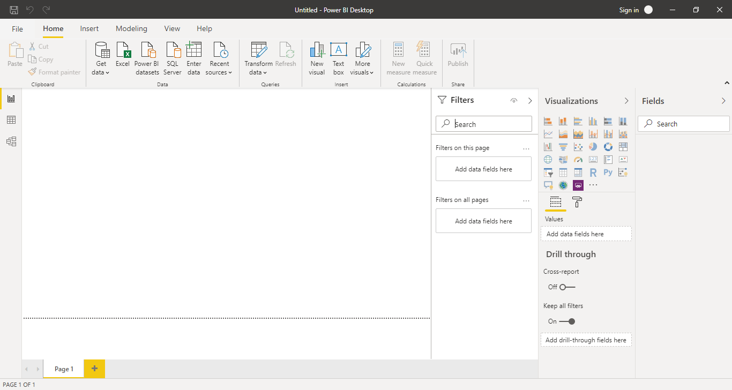

**Data View**

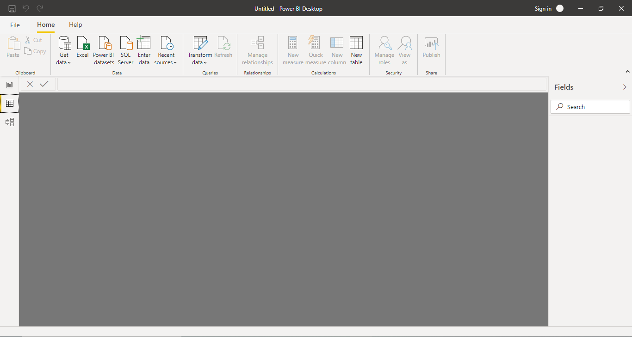

**Model View**

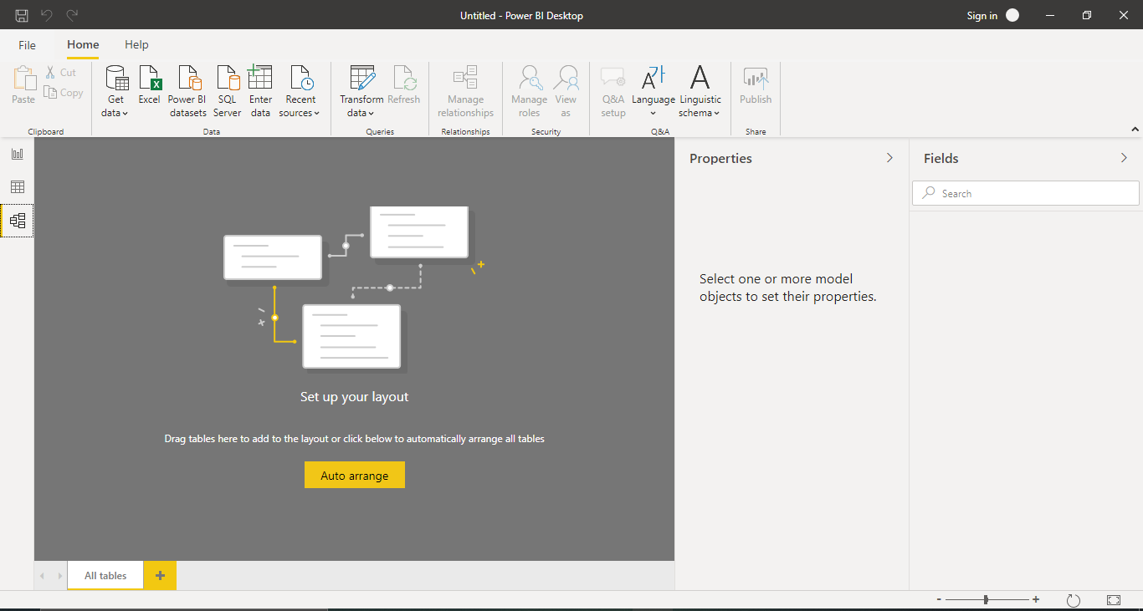

**Power Query Editor**

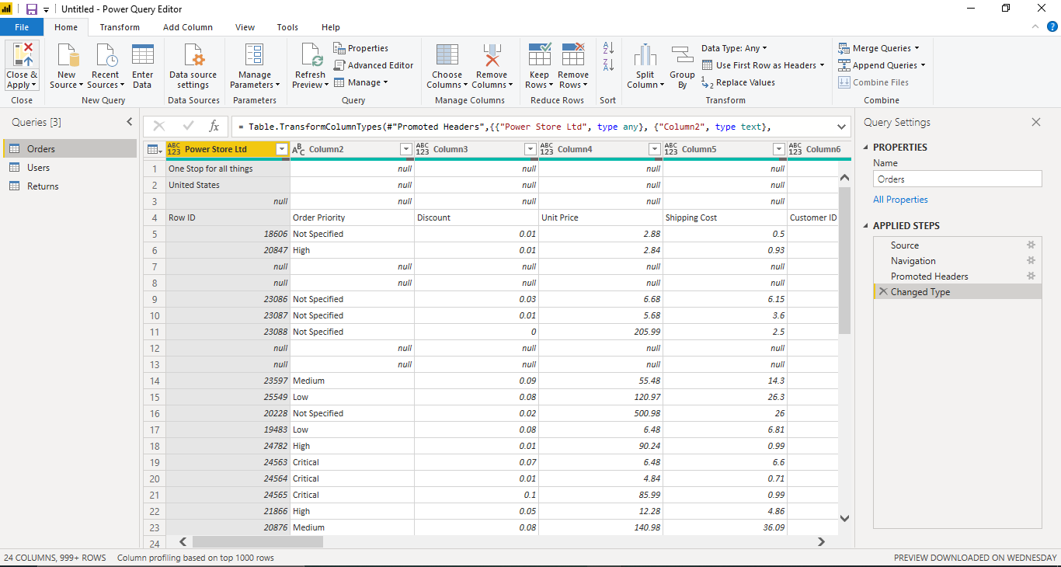

**Advance Editor**

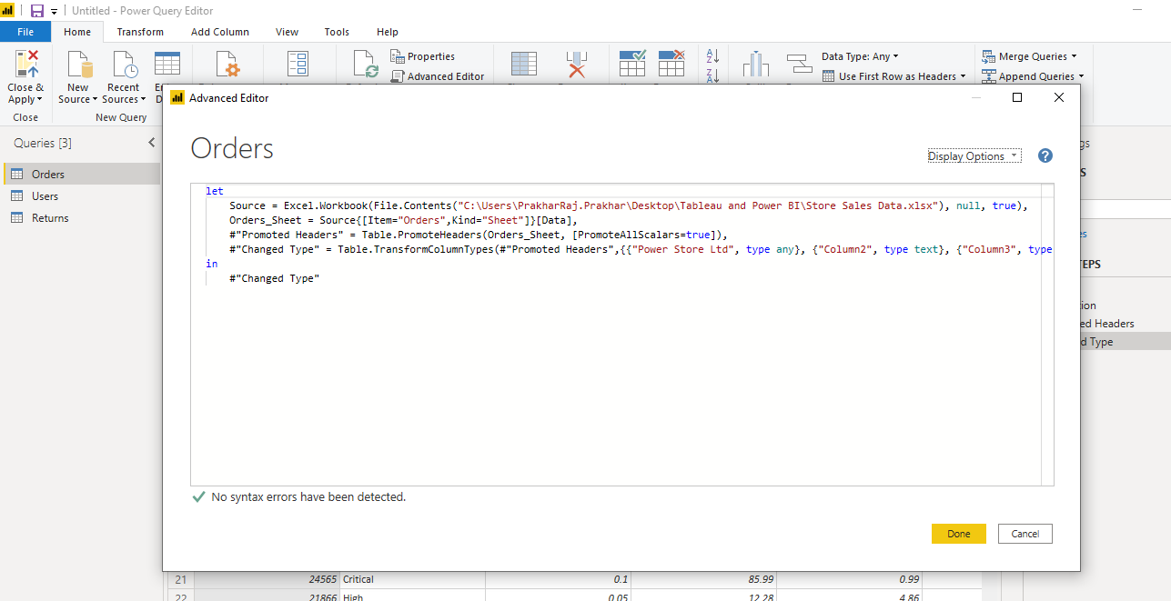

**Power BI Desktop :** *Power BI Desktop* is a free application you install on your local computer that lets you connect to, transform, and visualize your data. With Power BI Desktop, you can connect to multiple different sources of data, and combine them (often called *modeling*) into a data model. This data model lets you build visuals, and collections of visuals you can share as reports, with other people inside your organization. Most users who work on business intelligence projects use Power BI Desktop to create reports, and then use the *Power BI service* to share their reports with others.

The most common uses for Power BI Desktop are as follows:

* Connect to data
* Transform and clean that data, to create a data model
* Create visuals, such as charts or graphs, that provide visual representations of the data
* Create reports that are collections of visuals, on one or more report pages
* Share reports with others by using the Power BI service

**Price :** Free of Cost

**Power BI Pro:** Power BI Pro is an individual user license that lets users read and interact with reports and dashboards that others have published to the Power BI service. Users with this license type can share content and collaborate with other Power BI Pro users. Only Power BI Pro users can publish or share content with other users or consume content that's created by others, unless a Power BI Premium capacity hosts that content. For more information about the available types of licenses and subscriptions, see Power BI licensing in your organization. To assign licenses in the Azure portal, you must be an owner of the Azure subscription that Power BI uses for Azure Active Directory lookups.

Price: **$9.99/user/month**

**Power BI Premium:**  Power BI Premium is a capacity-based offering that includes:

* Flexibility to publish reports broadly across an enterprise, without requiring recipients to be licensed individually per user.
* Greater scale and performance than shared capacity in the Power BI service.
* The ability to maintain BI assets on-premises with Power BI Report Server.
* One API surface, a consistent set of capabilities, and access to the latest features for embedded analytics.

Power BI Premium consists of capacity in the Power BI service exclusively allocated to each organization. The capacity is supported by dedicated hardware fully managed by Microsoft. Organizations can choose to apply their dedicated capacity broadly, or allocate it to assigned workspaces based on the number of users, workload needs, or other factors—and scale up or down as requirements change.

**Price : $4,995 a month**